**作业一**

**题目**

绘制sinx、cosx图像

----------------------------------------------------------------------------------------------

**源代码**

#绘制sin cos函数图像

import math

import turtle

""" #调试加速绘图用

turtle.speed(0)

turtle.delay(0) """

#无痕调整画笔坐标

def Go(x,y) :

    turtle.penup()

    turtle.goto(x,y)

    turtle.pendown()

#画坐标轴箭头

def DrawArrow() :

    turtle.fillcolor("black")

    turtle.begin_fill()

    turtle.left(150)

    turtle.forward(10)

    turtle.left(120)

    turtle.forward(10)

    turtle.left(120)

    turtle.forward(10)

    turtle.end_fill()

#绘制坐标轴

#绘制x轴

turtle.write("0",font=("",15,"normal"))

turtle.forward(350)

turtle.write("x",font=("",15,"normal"))

DrawArrow()

turtle.setheading(0)

turtle.backward(350*2)

turtle.forward(350)

#绘制y轴

turtle.left(90)

turtle.forward(250)

turtle.write("y",font=("",15,"normal"))

DrawArrow()

turtle.setheading(90)

turtle.backward(250*2)

turtle.forward(250)

#绘制sin函数

Go(-300,0)

turtle.pencolor("Blue")

for i in range(-300,301) :

    x = i*(2*math.pi/100) #turtle画布中每100个单位为三角函数的一个周期

    y = math.sin(x)*100

    turtle.goto(i,y)

#标出经过x轴时的坐标及函数名

    if(i == -275) :

        turtle.write("y=sinx")

    if(i%50 == 0 and i != 0) :

        turtle.write(str(int(i/50))+"\u03c0",font=(9))

#绘制cos函数

turtle.pencolor("red")

Go(-340,-15)

turtle.write("y=cosx")

Go(-325,0)

for i in range(-325,276) :

    x = i*(2*math.pi/100)

    y = math.cos(x)*100

    turtle.goto(i,y)

turtle.done()

----------------------------------------------------------------------------------------------

**运行结果**

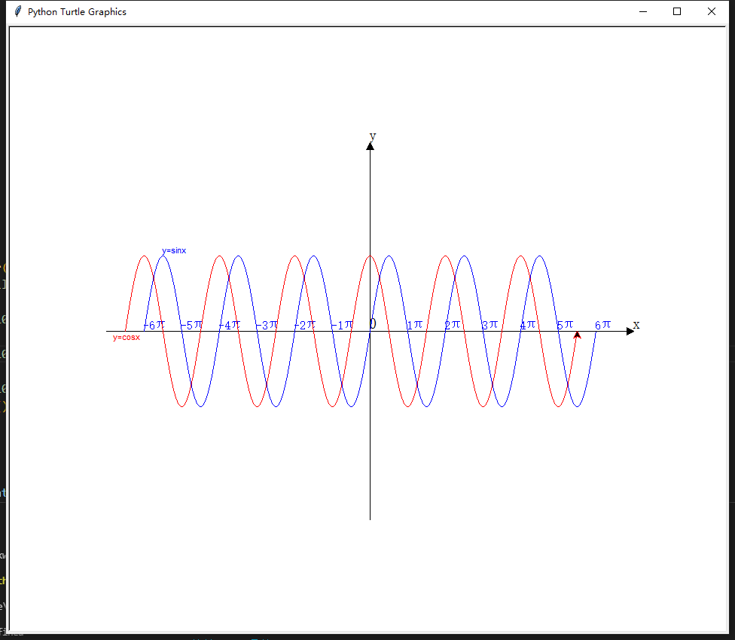

----------------------------------------------------------------------------------------------

**作业二**

**题目**

绘制y=x^2图像

----------------------------------------------------------------------------------------------

**源代码**

#绘制抛物线图像

import turtle

#调试加速绘图用

turtle.speed(0)

turtle.delay(0)

#无痕调整画笔坐标

def Go(x,y) :

    turtle.penup()

    turtle.goto(x,y)

    turtle.pendown()

#画坐标轴箭头

def DrawArrow() :

    turtle.fillcolor("black")

    turtle.begin_fill()

    turtle.left(150)

    turtle.forward(10)

    turtle.left(120)

    turtle.forward(10)

    turtle.left(120)

    turtle.forward(10)

    turtle.end_fill()

#绘制坐标轴

#绘制x轴

turtle.write("0",font=("",15,"normal"))

turtle.forward(350)

turtle.write("x",font=("",15,"normal"))

DrawArrow()

turtle.setheading(0)

turtle.backward(350*2)

turtle.forward(350)

#绘制y轴

turtle.left(90)

turtle.forward(350)

turtle.write("y",font=("",15,"normal"))

DrawArrow()

turtle.setheading(90)

turtle.backward(350*2)

turtle.forward(350)

#绘制函数图像

Go(-15,225)

for i in range(-15,16) :

    turtle.goto(i,i*i)

turtle.write("y=x^2")

turtle.done()

----------------------------------------------------------------------------------------------

**运行结果**

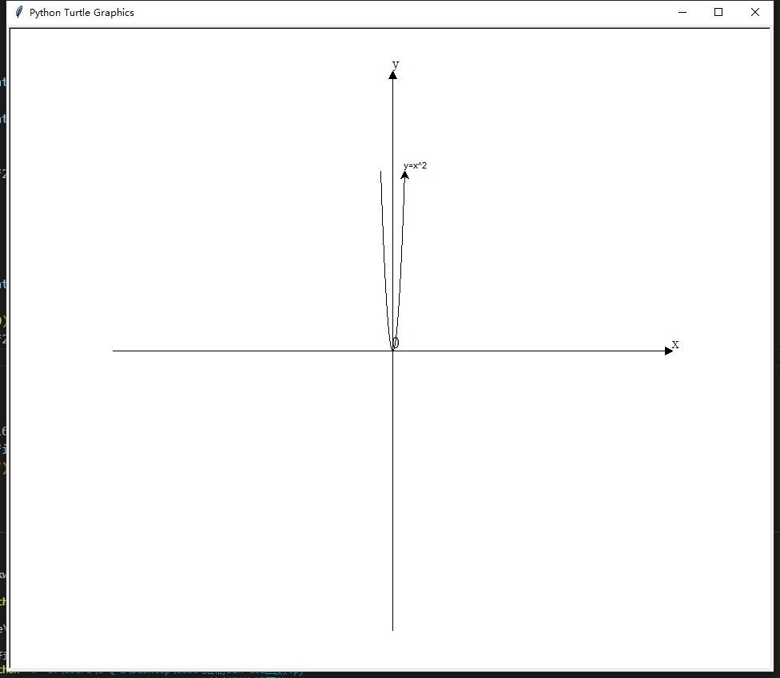

----------------------------------------------------------------------------------------------

**作业三**

**题目**

绘制五星红旗

----------------------------------------------------------------------------------------------

**源代码**

import turtle

""" turtle.speed(0)

turtle.delay(0) """

#无痕调整画笔坐标

def Go(x,y) :

    turtle.penup()

    turtle.goto(x,y)

    turtle.pendown()

#传入朝向画小五角星

def DrawSmallStar(degree):

    turtle.seth(degree)

    turtle.fillcolor("yellow")

    turtle.pencolor("yellow")

    turtle.begin_fill()

    for x in range(5):

        turtle.forward(38.0417418)

        turtle.right(144)

    turtle.end_fill()

#国旗大小600*400

turtle.pencolor("red")

turtle.fillcolor("red")

turtle.begin_fill()

Go(-300,200)

turtle.goto(300,200)

turtle.goto(300,-200)

turtle.goto(-300,-200)

turtle.goto(-300,200)

turtle.end_fill()

#绘制大五角星

Go(-200,160)

turtle.pencolor("yellow")

turtle.fillcolor("yellow")

turtle.begin_fill()

turtle.setheading(288)

for i in range(5):

    turtle.forward(120)

    turtle.right(144)

turtle.end_fill()

#第一个小五角星

Go(-100 - 17.3145, 160 - 6.174)

DrawSmallStar(48.96347)

#第二个小五角星

Go(-60 - 19.7948663580, 120 - 2.857143)

DrawSmallStar(36.213211)

#第三个小五角星

Go(-60 - 19.5, 60 + 5.714285848)

DrawSmallStar(5)

#第四个小五角星

Go(-100 - 17.2, 20 + 15.99999)

DrawSmallStar(-35.1301)

turtle.hideturtle()

turtle.done()

----------------------------------------------------------------------------------------------

**运行结果**



